**Service Oriented Architecture**

Joshua Harrison

838252

February 2018

Part A. External Architecture

Question 1:

The main roles in the overall architecture as listed below:

1. *Content Provider*: The content provider will be responsible for uploading and maintaining the content in the MightyMooC system. After they have been through the registration process they can make POST requests to submit module content. The interoperable nature of SOA means that a content provider could form many guises, and may not be strictly limited to an established university. For example, established business leaders might sign up to the platform to offer management and leadership courses.
2. *Student*: The student would be the primary consumers in the system. With the ability to enrol on modules or whole courses to gain qualifications, but with no ability to edit any of the content to which they have enrolled. They would be charged on a pay per module basis.
3. *Admin*: Internal MightyMooC staff users. They would use the system to handle vetting content providers and submitted content to ensure that it was up to standard as well as dealing with payment issues such as requests for refunds.
4. *Corporates*: Business account could be used as a parent with many child users and credited with a certain amount of content on a pay per module basis.
5. *External examiners*: Examiners from university with the responsibility of marking student assessments and providing quality control on subject matter.

Question 2:

The below table is provided as a reference for the core service that would be required to implement a minimum viable product for a fully operational system.

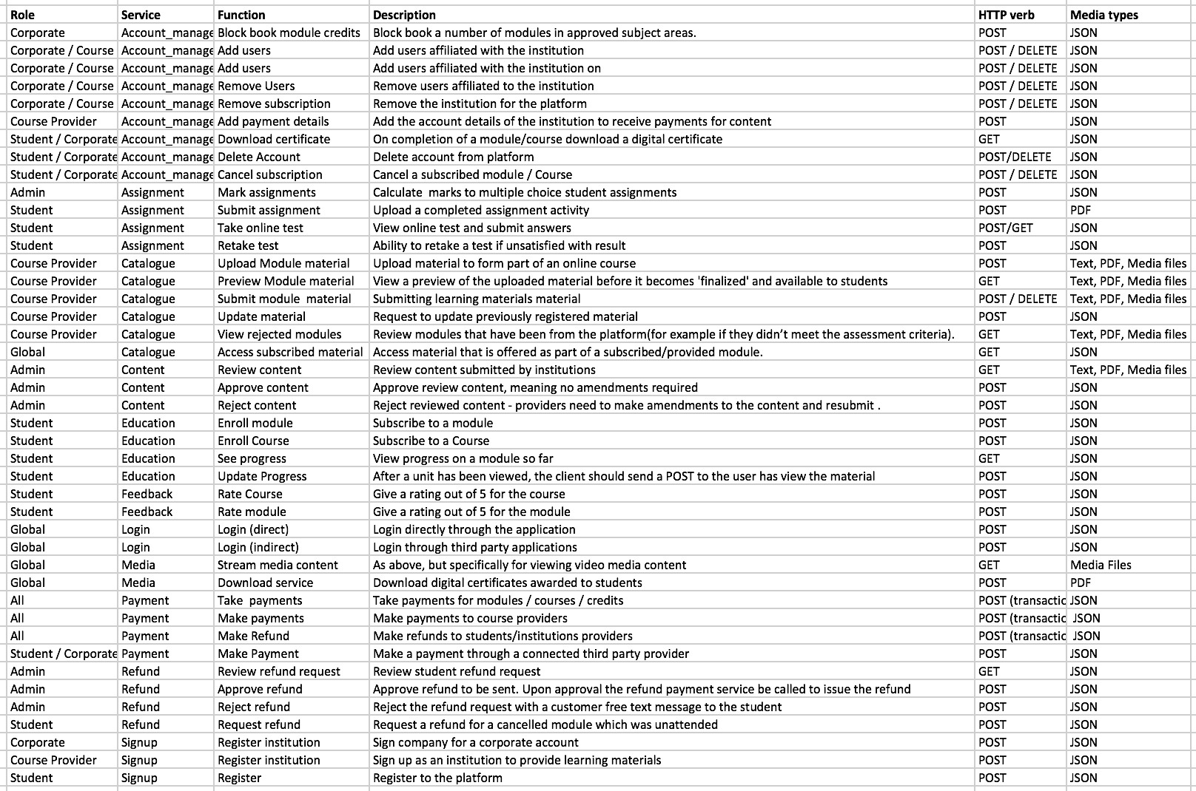

Question 3:

A skeleton schema has been created using the Python Library SQLalchemy. The full schema is listed in appendix A. Omitted from this schema is the structure for the content that course providers would upload to the system. This could take a number of forms, but the most suitable would be a JSON object with the following definition:

Name: string

description: string

tags: [array]

institution: string

content: { JSON object containing main body of content }

There would be no limits on the length on text, however the text it would be enforceable that uploaded modules had to fit this format. The structured nature of this data would enable for dynamic delivery of content to the frontend for end users. Further it would enable better interoperability between external service consumers through well-defined and consistently formatted output.

The system has two core levels of abstraction for content: a *‘module’* and a ‘*course’.* The module is single unit of educational material covering one specific area of study. A course is a logical grouping of modules with a common theme. Students would have the ability to sign up for both individual modules and complete courses, and the loose coupling between modules and courses would facilitate the ‘build your own degree service’. The schema design for modules and courses has been implemented with both having many to many relationships with course providers, meaning that a multiple course providers can contribute content towards a module or course.

Name: string

description: string

modules_ids: [array]

institution_ids: [array]

Question 4:

REST has been chosen as the technology interface for the SOA. This is due to its wide spread adoption as a framework, and the growing move anyway from SOAP architectures in general. Whilst the benefits of language definitions through WSDLs are an advantage of SOAP, and in many ways the content upload schema defined previously would be well suited to XML, such schemas can also be implemented and maintained through JSON through the use of the OpenAPI standard (formally Swagger). The widespread adoption of the REST framework is advantageous programmatically as there are a plethora of external tools such and libraries dedicated to implementing elements of the REST framework. This project (which has been built using Python) uses Flask, Flask-SQLalchemy, Werkzeug, flask-RBAC, and Postman (for testing) all of which are examples of tools either specially designed for REST application development or which assume REST at their core.

Question 5:

The Catalogue service was created as a multiple purpose service to access and edit data in the MightyMooC catalogue for both students and content providers. For example students accessing the catalogue service would be able to make GET requests to list all content provided by a given institution, they would also be able to make POST requests to enrol on any courses or modules, and DELETE requests to cancel their enrolments. Content providers would to make the same GET requests as students and additional POST requests to add content to the catalogue. DELETE request which are made send ‘soft_delete’ signals to the MightyMooC backend as no module should be completely purged at will.

The Postman was used as a testing suit for the API endpoints later in the process (see part B). Postman is a powerful tool as can able to generate API documentation in JSON format concurrently to testing the endpoints. This JSON can then be exported and loaded into the *Swagger editor* to generate documentation in the OpenAPI format, or Postman’s online document hosting platform can be used as an alternative. *Figure xx* shows a sample extract from the Postman generated documentation (full documentation in appendix xx).

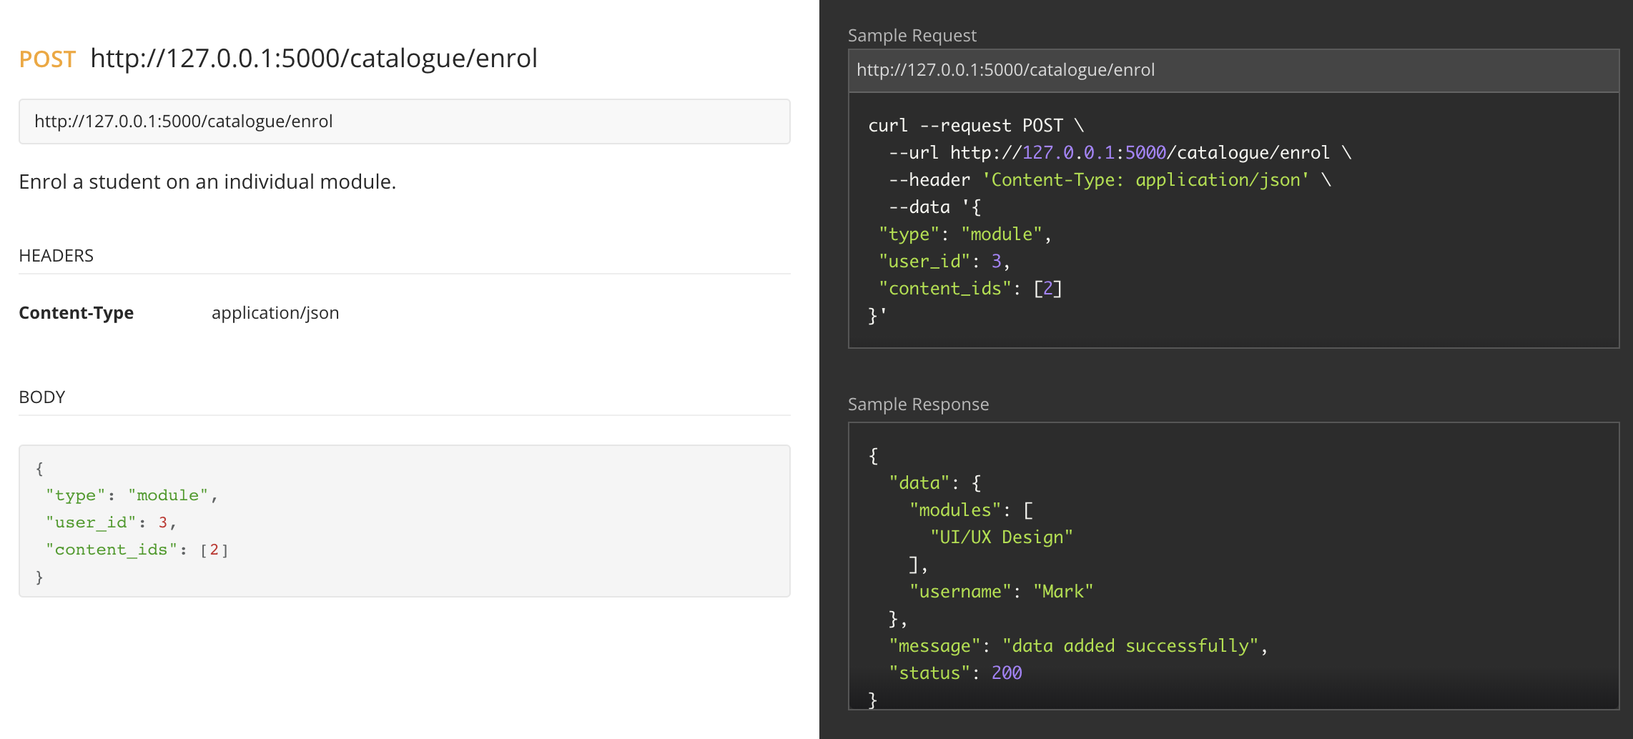

*Figure xx: Postman documentation for the catalogue/enrol endpoint*

In Figure xx we see the documentation a POST request to the *catalogue/enrol* service endpoint. This request would be made by a client to enrol a student to a given module or course. Here we can see that the endpoint headers are application/JSON data and the JSON in body includes the data detailing the enrolment request. The right hand output shows a sample curl request (Postman Documenter has an added advantage of being able to create sample requests in a number of popular languages). Also shown in the right hand display is the sample response which is generated from the sample output. Here we can see a success message and echoed back the module and user pairing which has now been enrolled.

Question 6:

As well as the core services described previously, the interoperability of the model lends itself to the creation of several ancillary services. These are listed below:

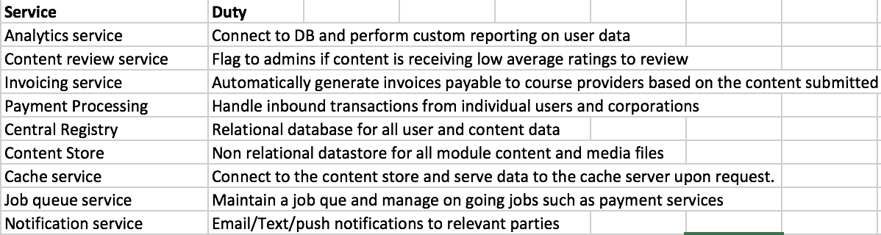

*Figure xx: Ancillary services required of an minimal viable product of MightyMooc.*

Question 7:

The below diagram shows the external facing components for the architecture.

**Part B.**

The project has been designed using a *'top down’* modelling implementation, meaning that prior to code creation and schema definition, a prerequisite step is to analyse and deconstruct the central business requirements to the problem. This approach is considered best practice for SOA projects as it enables a global definition of services and their capabilities allowing logical boundaries to be defined, leading to increased ubiquity, reduced code overlap between services, and crucially, increased interoperability and composability of services. [REF]

There are caveats that can limit the success of implementing a top down design that should be considered. Namely, as a project progresses it naturally evolves, unexpected challenges and edge cases can arise; subsequently new functionality and consumer roles can be added or removed. The planning and documentation generated from the top down design needs to be sufficiently flexible to facilitate the organic evolution of a project. A tightly scoped top down project will only succeed if its implementation is unobstructed by inflexibility and rigour.

A secondary concern is speed of development iterations which can suffer as a result of top down design. With a top down design process comes the overhead of increased pre-build requirements. Top down designs front-load the required man hours due to a greater emphasis placed on problem decomposition, analysing required service models and defining service contracts (Erl, 2010, pg. 94). However, the alternative of allowing developers to build first and define contracts and documentation after or during the build process (bottom up design) for the gain of quick iteration and agile development comes with a high probability that the code produced will be less interoperable to both internal and external service consumers.

Figure 1 depicts the top down design approach that that is utilised by this project. This design has been adapted from Erl’s original specification ‘SOA project and lifecycle phases’ (2010, pgs 92-103). Phases related to the wider business context of SOA, such as organizational buy-in/adoption, service discoverability and versioning have been omitted.

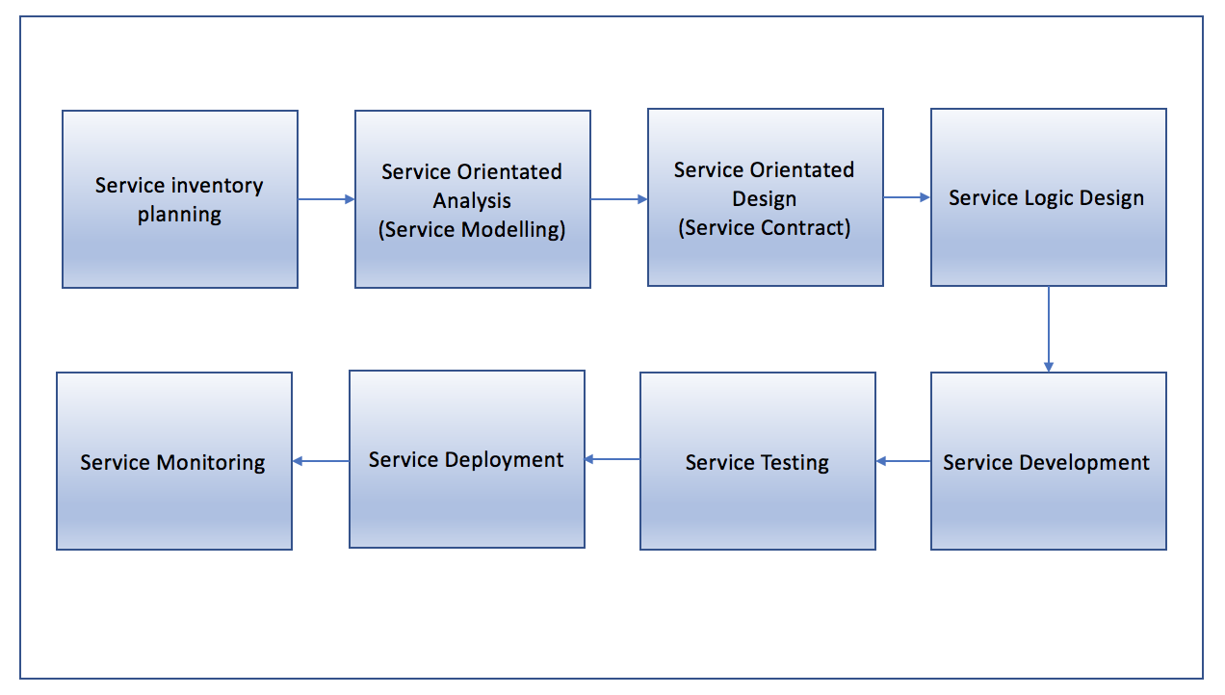

*Figure 1xx: Project design phases*

**Service Inventory Planning (SIP)**

Erl (2005, pg. 96-97) defines SIP as a cycle which aims to produce a *‘service inventory blueprint’* from which services will be built. The blueprint is derived from following the cycle depicted in Figure 2. The application of this cycle in this project is detailed below.

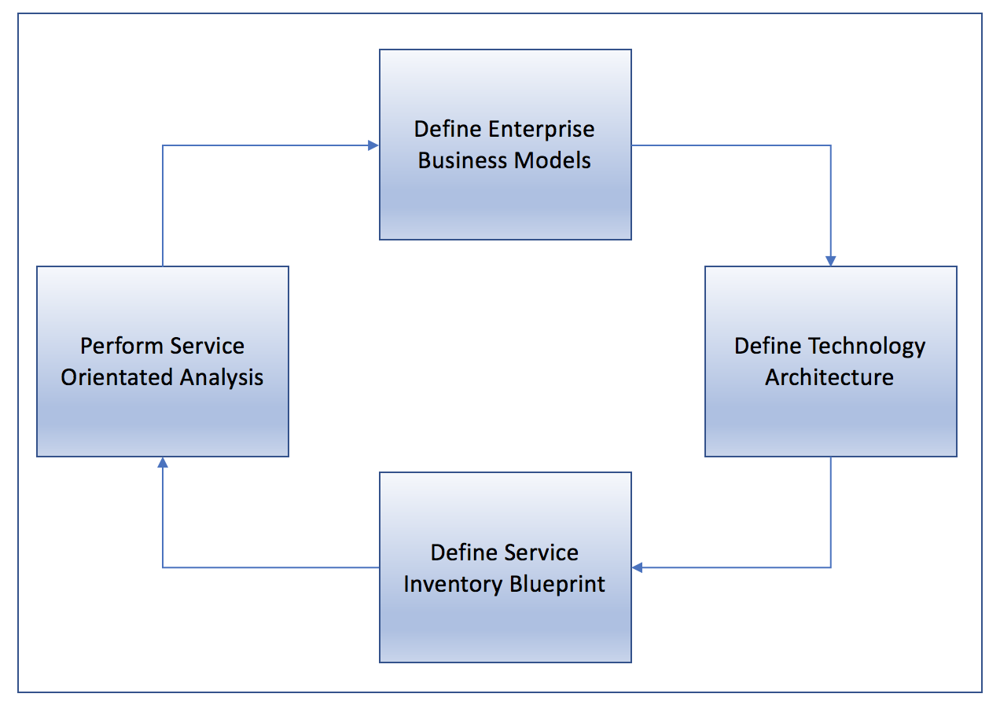

*Figure xx: Service Inventory Analysis Cycle, Source: Erl. 2005, P.g. 96.*

**Define Enterprise Business Models**

This phase typically involves analysing existing and required business process and entity models to conceptualised fundamental requirements of the service inventory. The following core business process definitions were asserted as the core goals of *this* business process:

1. Many course providers can offer many courses to a collaborative collection of material.
2. Qualifications from disparate course providers can be ‘bundled’ to form a single qualification.
3. Students can sign up for a single standalone ‘module’ from a course provider or to a larger qualification offered from one or multiple institutions.
4. Course providers need to be able to provide content for modules, this may be in various media types (PDFs, Video Media Files etc.)
5. Students need to be able to access content at low latency at any time.
6. Students need to able to submit module assessments.
7. Course providers need to be able to access student submissions; providing grading and feedback to them.
8. Students need to be able to download any certificates awarded as a result of completing a given module/course.

In addition to these corerequirements, there are also several ancillary requirements for a fully functional system, such creating an account, logging in, making payments and processing payments and refunds. A deeper analysis of these ancillary tasks has been omitted from this phase of the report as they are typical in web application and not unique to *this* project.

Upon decomposing the core units; a key design choice arises. Should a centralised database of content be used for content providers to upload their material, or alternatively, should institutions store all content locally allowing the MightMooC service to connect to the content providers and *lazily* access the content as and when requested from an end-user client?

Decentralised content storage has several pragmatic advantages as it allows institutions to maintain their own content locally. This means that any issues of sharing intellectual property with a third party service, and the potential security concerns that come with this, are avoided.

There is an interesting consideration in the decentralised content infrastructure regarding the relationship between course popularity and bandwidth constraints on the course providers. If content was POSTed to the MightyMooC service lazily upon request, *the bandwidth consumed by the course provider would be a function of the number of concurrent requests*. Given the assumption that the more subscribers on a course the greater probability of concurrent requests, course providers would become burdened with a high volume of requests at spiking times. Put another way, *the predicted quality of service for a given module of content is inversely proportional to the number of subscribers to that content.* This is a serious limitation and one that could affect the success of the platform.

One potential solution would be to the use of internal caching servers such as *Redis* to temporally store the content following a GET request from an external client. This way, MightyMooC could make a single GET request to the content provider and cache the response. Any clients subsequently requesting the same content would have it served from the cache server. This has the additional benefit of optimising performance through data locality. Cache servers could be physically located in a cloud infrastructure in various global regions, enabling regional caching and serving of data to match the origin of inbound client GET requests.

There are however several issues with this design. A large problem is that is breaks the principle of *service loose coupling*. In the decentralised storage model there is tight coupling between the course provider and the content being served. If for any given reason a university suffered an availability fault in its own infrastructure, any subscribed students would not be able to access the enrolled content. Whilst arguably this is a greater issue in a centralised data storage platform as it introduces a single point of failure for all content, the fact that the data storage would be handled internally allows for controls, optimisations and provisions for redundancy to reduce risk of service disruption.

A further advantage of using a centralised storage platform is bandwidth efficiency. If all service providers were using in house storage mechanisms to serve data to MightyMooC, data would be sent across the wire whenever MightyMooC made a request for content. With a centralised data platform, MightyMooC would simply have to retrieve the requested data internally and then serve it to the client. This also brings security benefits as there is data is less frequently in transit, meaning less opportunity for interception attacks.

A final more pragmatic advantage of storing content centrally is that it mitigates any chance of content providers drastically changing content out of the control of MightyMooC. Whilst content providers should be able to control and change their content if required, if given complete autonomy over this process the ephemeral nature of the content could lead to problems for end users. For example different users enrolling at the same time could access different content, or even different assessments for a given module. This also means that MightyMooC can better specify and document the expected format of content. Which will allow for better interoperability with external APIs and dynamic content generation on the frontend.

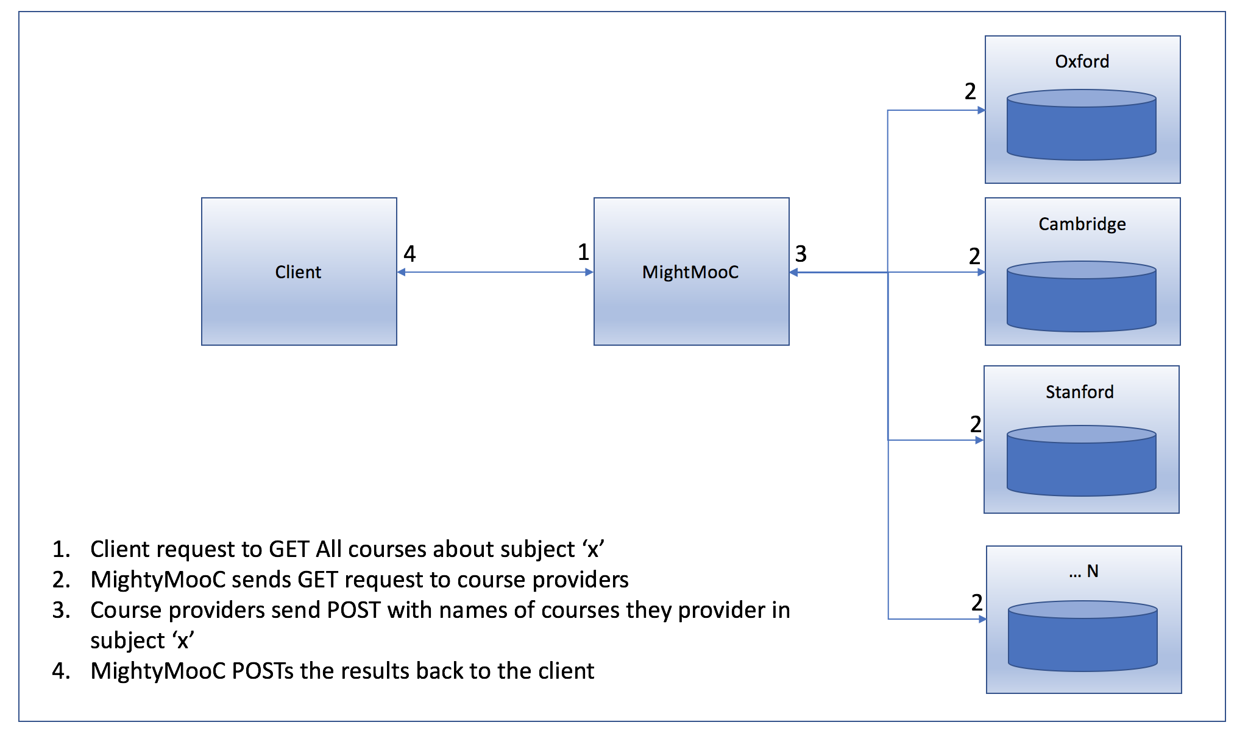

*Figure 3: An example of a system whereby content storage is handled locally by the course providers and lazily served upon request. Here we see the process by which an end user would search for courses in a given subject.*

**Define Technology Architecture**

Given the above discussion it was considered that a centralised content store to which content providers would upload material was the most stable architecture. The discussion around caching and data locality are still relevant and have been incorporated into the architecture design.

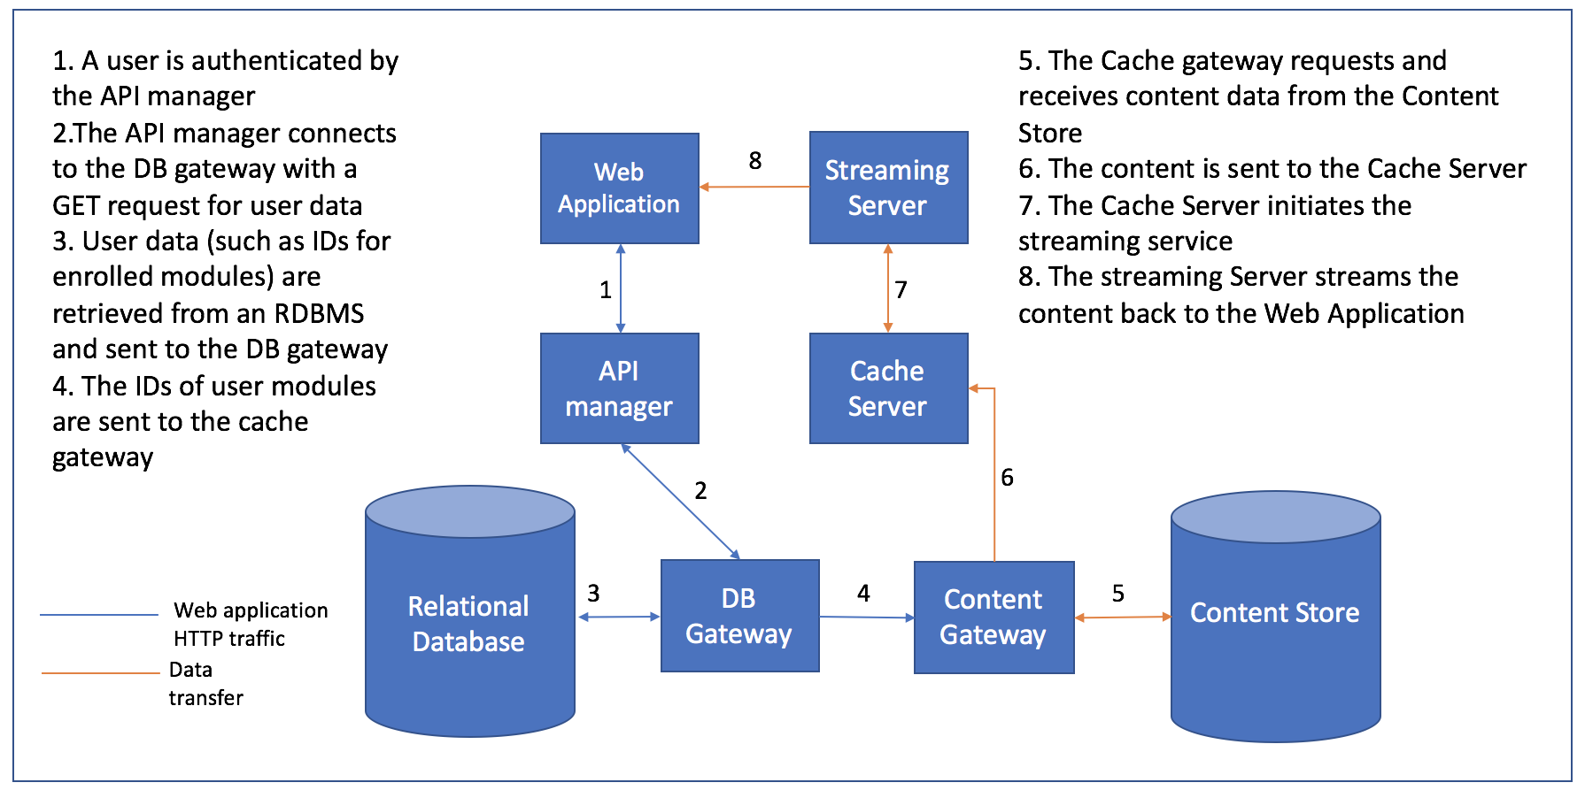

*Figure 4: MightyMooC technology architecture and example data flow for a video stream.*

*NOTE TO SELF: check the API manager is in the correct position (as opposed to position 1)*

**Key Technology**

**Web Application**

A frontend connection to a headless API using the REST framework. This can be seen as an *API* first approach as the API and services behind it will be built up with the frontend component completely detached from the backend architecture. This has offers excellent flexibility to both components and adhere to the principle of loose coupling.

**API Manager**

Handle the inbound authentication process and ferrying HTTP requests through the API.

**Database Gateway**

Act as a conduit to the database to ensure that any requests to the database are authenticated**,** that the database server is not exposing any ports directly to the internet.

**Relational Database**

A traditional RDBMS tasked with storing non content specific data. For example tables such as users, modules, and users_modules would be stored here as well as metadata from generated from application activity. Given the nature of the data, there are no immediate scalability considered, and so a standard RBMS such as MySQL or Postgres would suffice. A skeleton schema is shown in appendix A.

**Content Gateway**

Analogous to the Database Gateway – provides a gateway into the Content Store.

**Content Store**

The Content Store is a data repository where all content provided by external providers would reside. This is liable to have scalability considerations as the number of providers participating in the system grows. Given that providers will upload a range of materials such as video media files, PDF, and a schemaless storage system with good scalability (such Amazon S3) would be a suitable solution. An alternative approach would be to use a NOSQL database as a document store such as MongoDB. This could have speed and analytics benefits in the long run as the implicit use of a schema will make querying and processing of structured data far more efficient than reading data from flat storage files.

**Cache Server**

A server to Cache media content from the Content Store upon request to enhance performance of streaming and reduce bandwidth usage. TO_COMPLETE what cache server to pick?

**Streaming Server**

A server which connects to the Cache server and streams content back to the web application for the logged in user to access.

**Define Enterprise Business Models**

A BaseService class was defined in python to act as a technological blueprint for any further services that are required. The BaseService class should contain all logic that is likely to be universal to all services in the project. This enables for quick iterations of service builds as once the base service has been conceptualised all future services can use inheritance and polymorphism to extend and override methods in the base service.

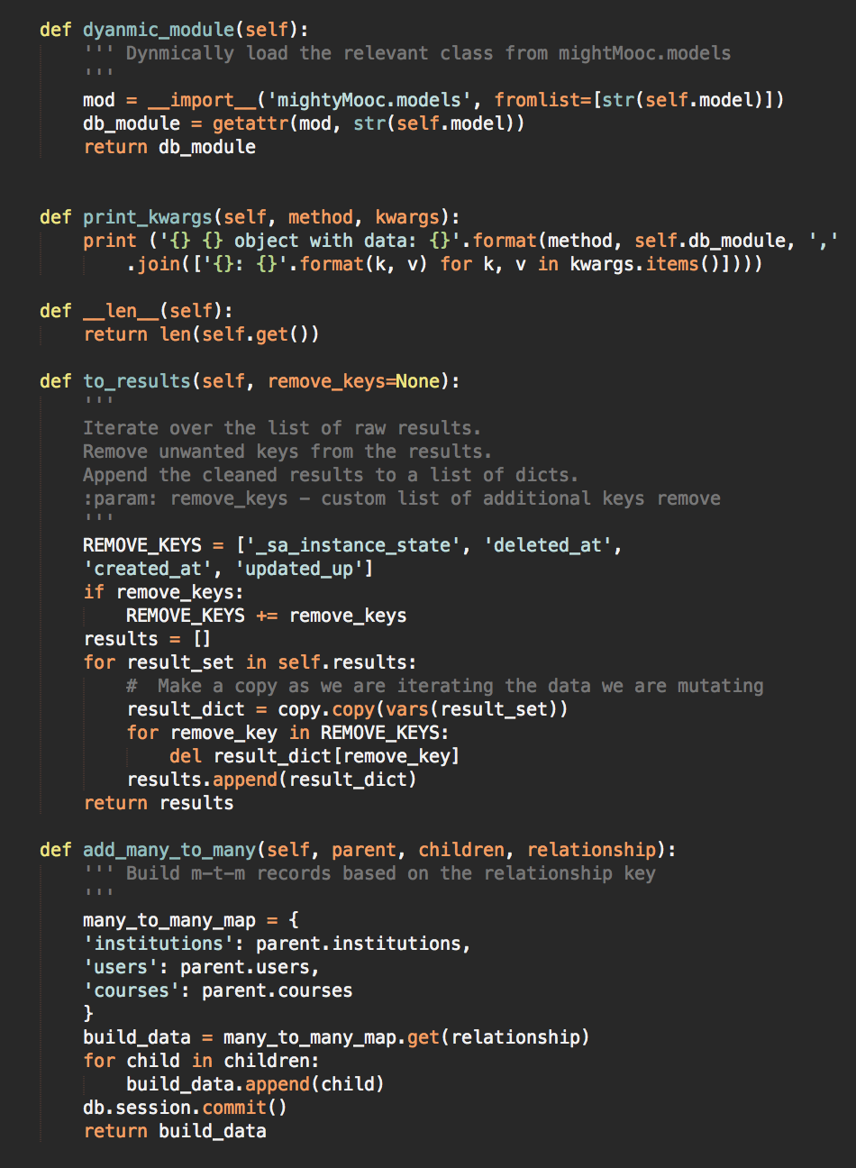

*Figure xx: Helper methods in the BaseService class*

Of note in *figure xx* are the methods ‘*to_results’* , *‘add_many_to_many’ and ‘dynamic_module’. The method* ‘*to_results’* is used to pre-process any data that is return from raw database lookups from an incoming GET request to a service. Given that each database model has a distinct schema, there is a requirement for the method to be able to finagle the data response to a more meaningful output to the end user regardless of the model that is being called.

The ‘*add_many_to_many’* method provides a means of creatingchildrecords in relational join tables. This can be triggered either directly (for example when a student makes a POST request to *catalogue/enrole* to sign up to a module/course) or as a side effect of a record being added to a parent table (for example when an institution adds a module through the *catalogue/add* endpoint).

The ‘dynamic_module’ method is critical as it dynamically loads the service and database modules required to interact with the service that is extending the BaseService at runtime.

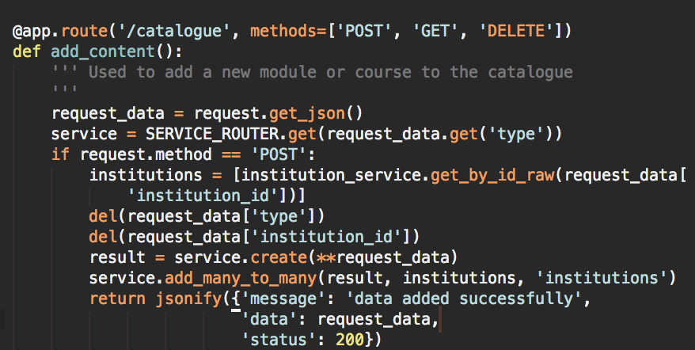

*Figure xx:* Here we see the route that is called when POST request is made to the catalogue service. The module is added to the catalogue and a then a call to add_many_to_many() is made to create a record in the modules_institutions table with foreign keys to the created module and the institution that sent the request.

The BaseService also contains several ubiquitous methods relating to CRUD operations. As stated previously the main of the BaseService was to become a technical blueprint for all future services built. In order for this to be a success we have to consider that service which do not yet exist may one day come to extend the BaseService. For this reason, to achieve the goal of *service reusability* conditional logic must be avoided from the control flow whether possible. This is challenging when considering database interaction as in order to retrieve and create records in the database we need explicitly call the target tables. Boolean logic fails to achieve service reusability here as the flow as static Boolean conditions can be used control the state of the machine as it currently stands and not in any future states. Consider the logical flow:

*If A:*

*Query table A*

*Else if B:*

*Query table B*

*Else if C:*

*Query table C*

This will work without issue if there are service consumers A, B, and C, however as soon a service D is added to the infrastructure the BaseClass itself will have to be extended to accommodate its new member. Extending the blueprint to fit new services defeats the purpose of a service blueprint! Instead the blueprint should be agnostic enough to handle any number of extended classes without knowledge of who those classes are or what their purpose is. This is inline with the principle of *service reusability* (Erl, pg. 295) and the ‘*agnostic capability design pattern’* (Erl, pg. 322).

In order to achieve this agnostic capability and extensibility of the BaseService the attribute *db_module* was added as to all services extended from the BaseService. This attribute is a pointer to the database module defined in which that service primarily interacts with.

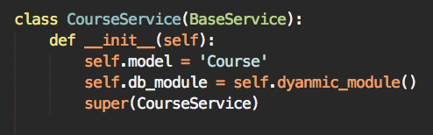 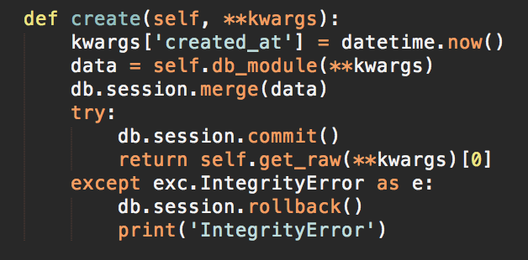

*Figure xx: The instanitation of the CourseService from the BaseService(Left). Here we see the attribute self.db_module being set using the self.dynamic_module() method discussed above. The create() method(right) comes from the BaseService class, and show the referencing of self.db_module to interact with the database rather than calling any database models directly.*

Another method worth noting for pragmatic reasons is the *‘soft_delete’* method. This is used for setting a deleted_at timestamp on the database record when a deletion request comes is made. This could either be in the form of a content provider deleting material or a student cancalling their registration on a course/module. In both of the instances the method checks that the source that made the request is the same source that created the record. If this check fails a *403* *forbidden* status will be raised. In a fully fledged system the request would obvioulsy have to authenticate themselves to the system through the API manager before any inbound requests could be processed.

The use of soft delete is important as content providers should not have the ability to remove content that they have submitted on their own accord at any time. This could lead to business problems and breaking terms of service if students attempted to access material which no longer existed.

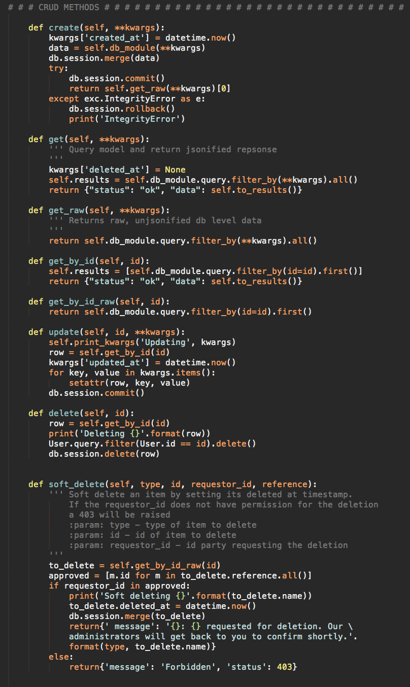

*Figure xx: BaseService CRUD operations*

**Testing the Catalogue Service**

In order to test the services a seed was used to create dummy data. This seed file is in itself a good means of testing the backend comments of the services as create methods are called on the various models to insert data. To test the API endpoints for the catalogue service the Postman software was used to craft various API requests and record their responses. These are details below.

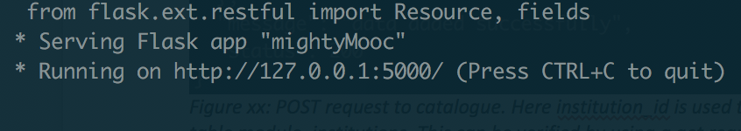

*Figure xx: Initialisation of the MightMooC application*

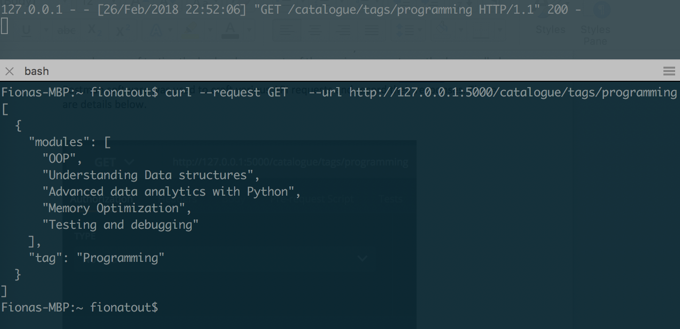

*Figure xx: Get request for items in the catalogue with the ‘programming’ tag*

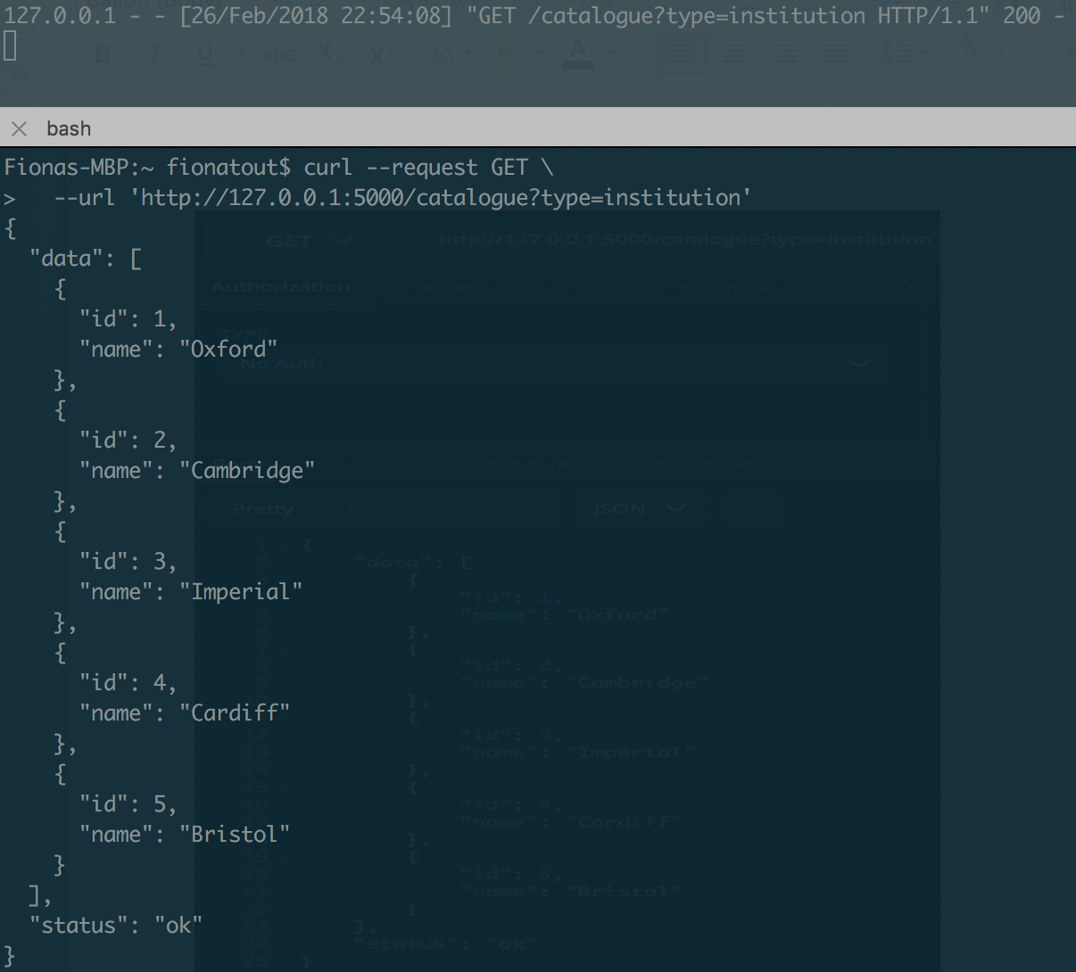

*Figure xx: GET request to catalogue send the type in the request arguments. Note, that send type=course or type=module are also suitable request arguments to this endpoint.*

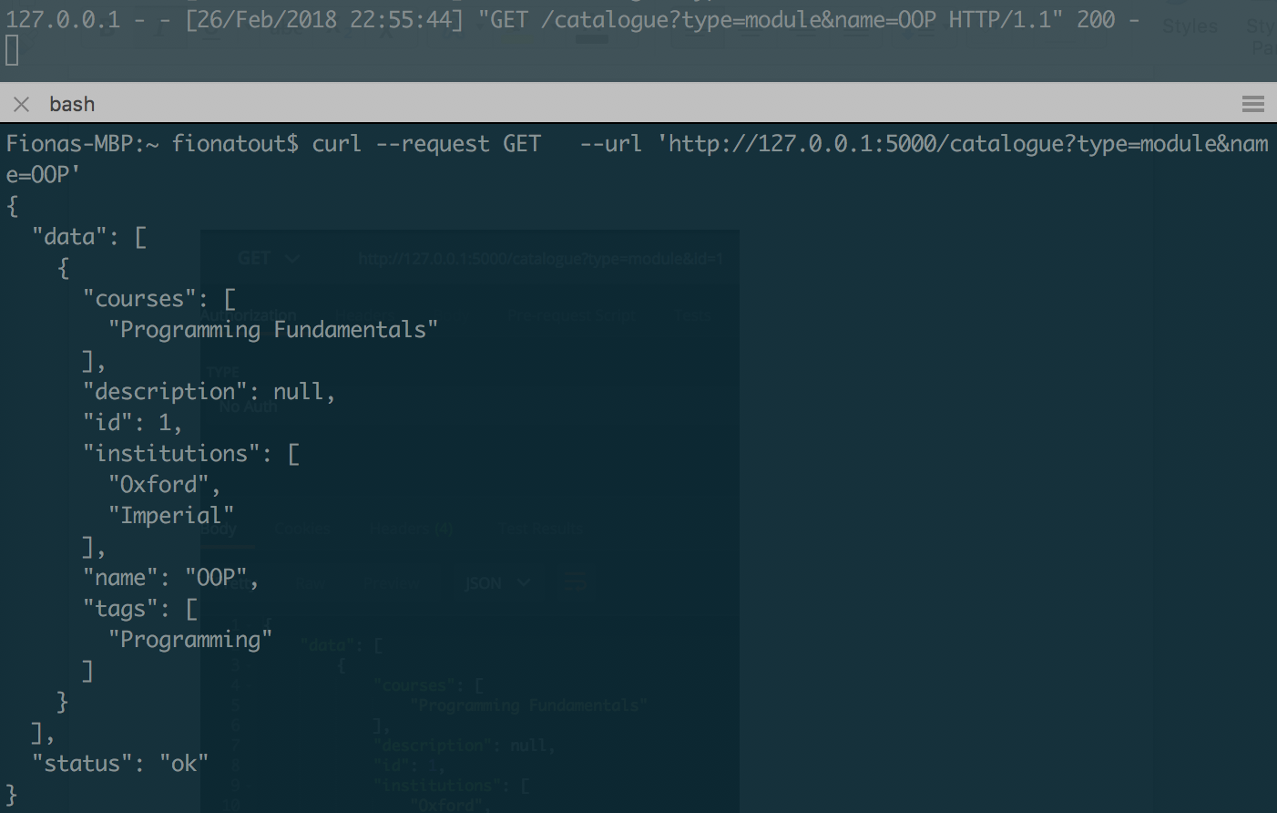

*Figure xx: GET request to catalogue. This follows the same pattern as figure xx above, but here we see an additional parameter sent in the URL using the ampersand syntax.*

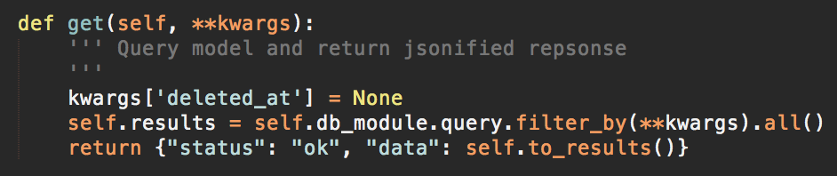

*Figure xx: Get method from the BaseService class.*

Figure xx shows the BaseService.get() method used inherently used for all GET requests in the service. Here the python **kwargs syntax indicates that the endpoint accepts an unspecific dictionary as an input. With this syntax it is possible to query any data in the model without having to explicitly set the request parameters in the code for the URL. For example the request ‘http://127.0.0.1:5000/catalogue?type=module&id=1&name==OOP’ is also valid. It is worth noting an important caveat, imploying such a method in a production environment should be done with a good deal of care to probably gate and validate the legitimacy of the incoming request. Allows unspecified conditional arguments could present a security vulnerability in the form of an injection attach if the arguments are no pre-validated.

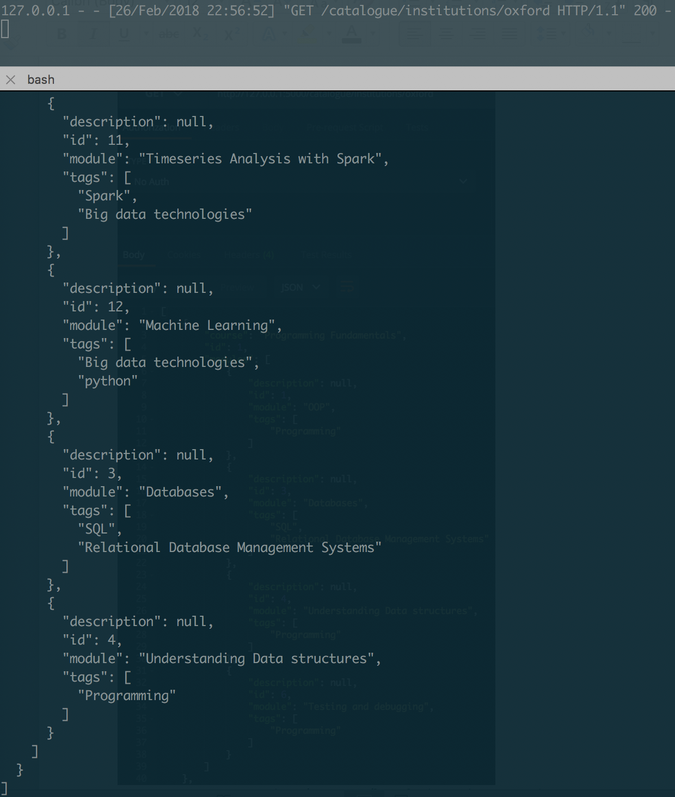

*Figure xx: Get request to catalogue/institutions/[name] – this results in a nested JSON response of the courses and their modules that the institution contributes content towards (output here is shortened).*

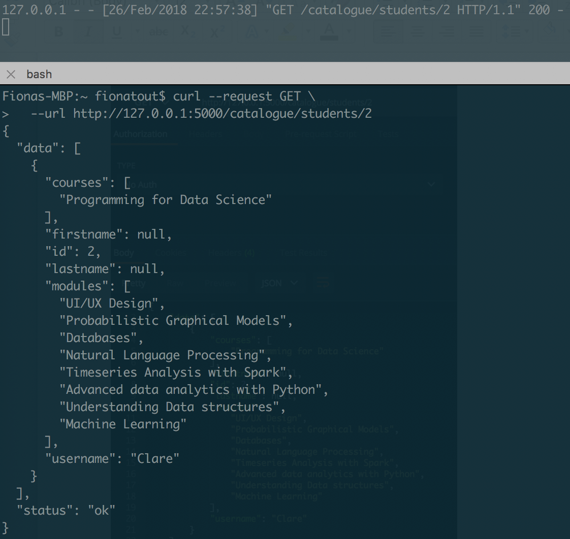

*Figure xx: GET request to the catalogue/student/[id] endpoint – here we see all courses and modules that the student has enrolled on.*

POST requests

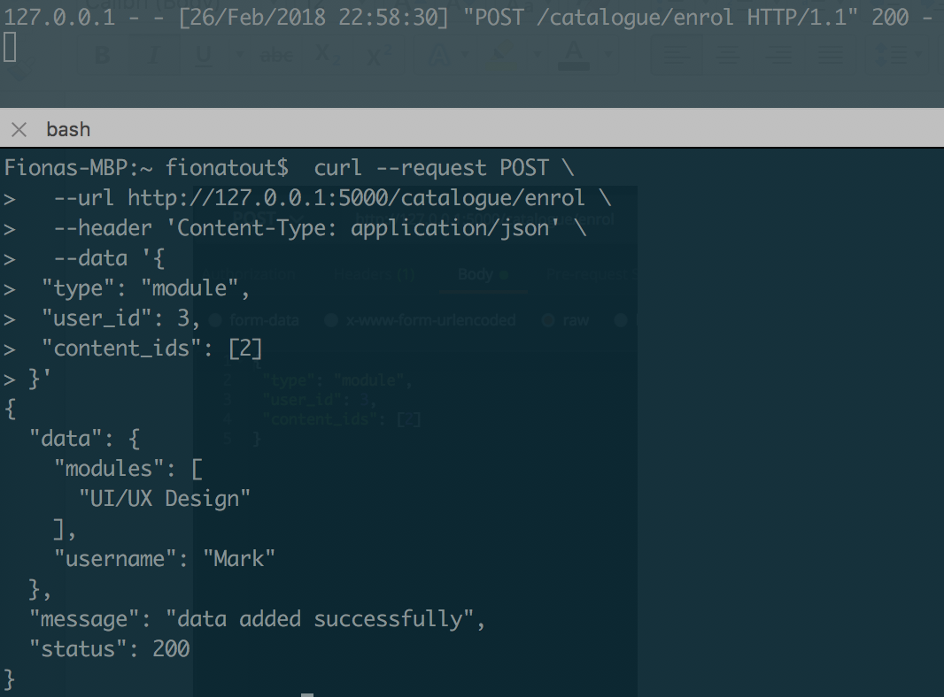

*Figure xx: A POST request to the catalogue/enrol service. The response shows us that the user ‘Mark’ has enrolled on the ‘UI/UX Design’ Module.*

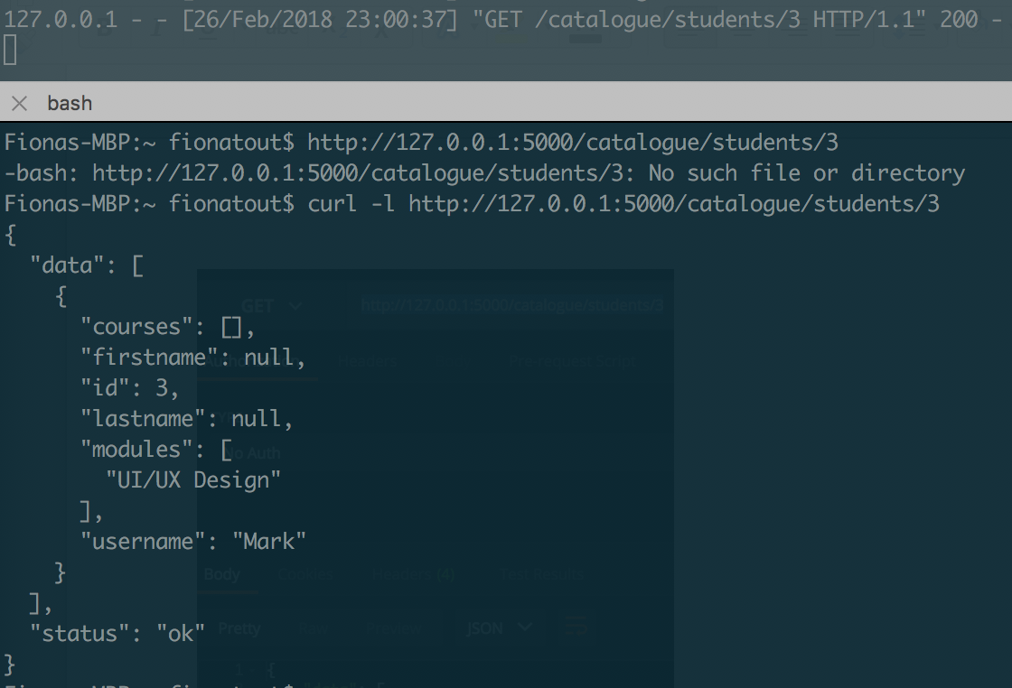

*Figure xx: Verification of the above POST request by making a GET request to catalogue/students*

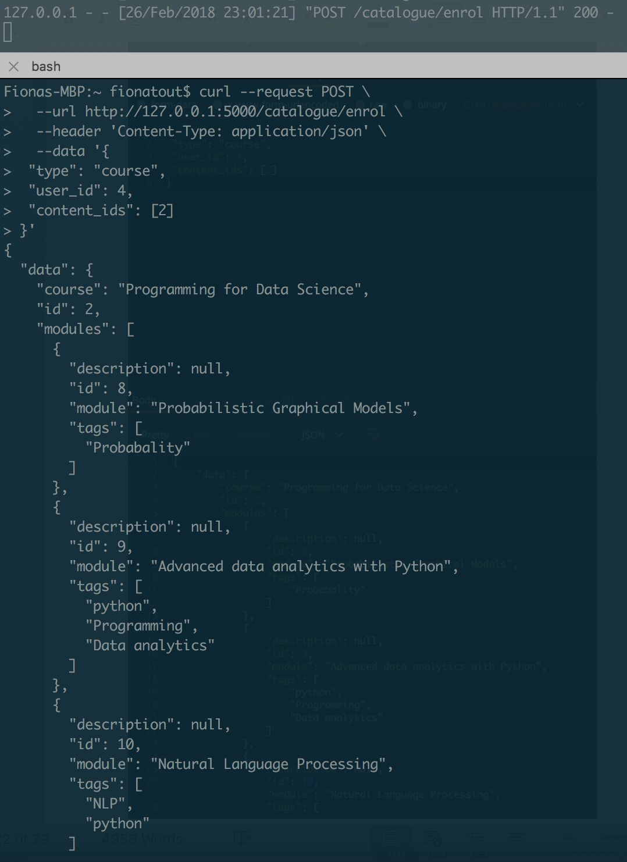

*Figure xx: A POST request to catalogue/enrol this time giving the ‘type’ argument in the JSON body as ‘course’. This has the effect of enrolling the student on the course and all modules that are children of the course (output abridged).*

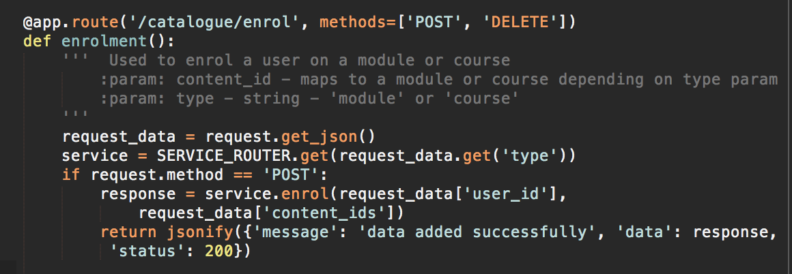

*Figure xx: Here we see the code that handles the above enrolment requests. The SERVICE_ROUTER.get dictionary is used to send the request to create the enrolments to either courses or modules based on the inbound JSON ‘type’ data. If a course is selected, the course.enrol service iterative subscribes the user to every module in that course (see appendix xx).*

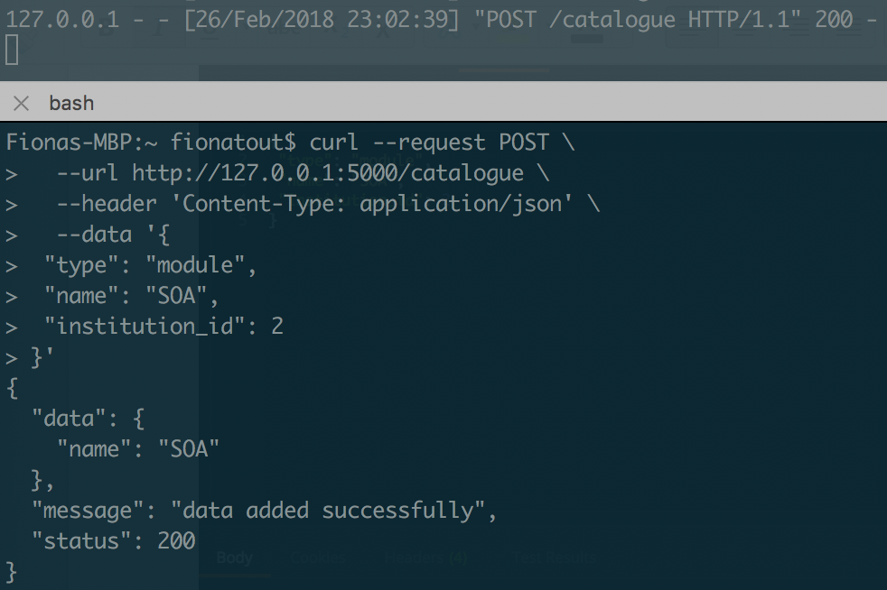

*Figure xx: POST request to catalogue. Here institution_id is used to add a record in the join table module_institutions. This can be verified by using a get request with the institution ID:*

DELETE requests:

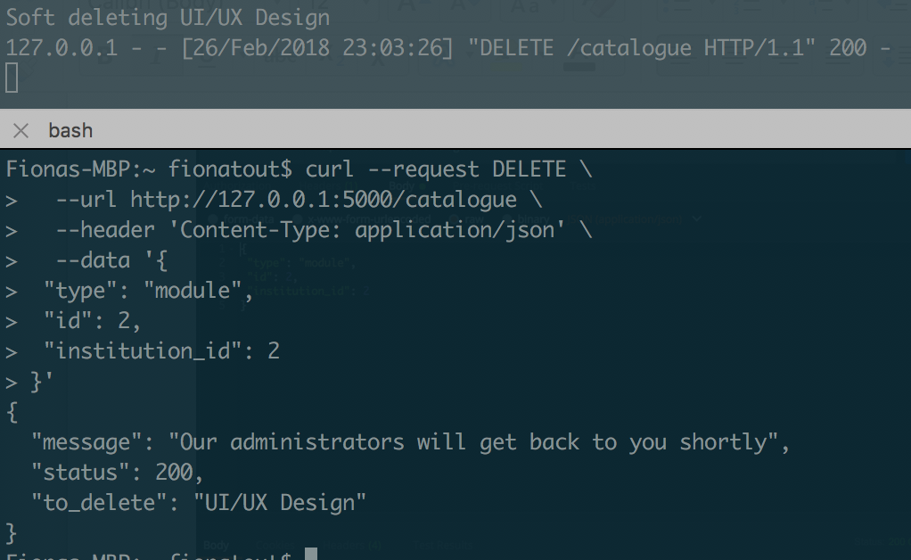

*Figure xx: Soft delete of a module from an institution, note this results in a 200 success as the institution_id 2 added the module originally (see seed file in appendix xx).*

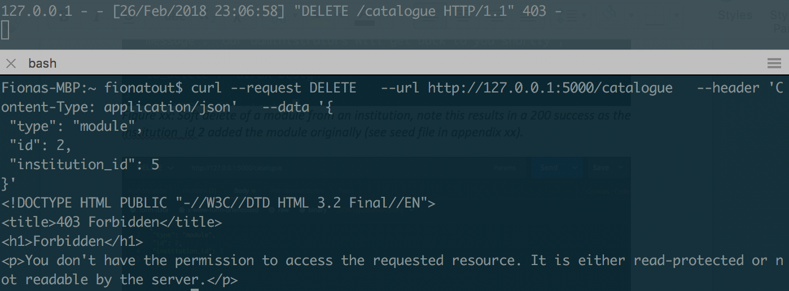

*Figure xx:* The equivolvent deletion request is made but by an institution that are not content owners. This time a *403 forbidden* response is raised. This mechanism is handled in the BaseClass.soft_delete() method detailed in figure xx.

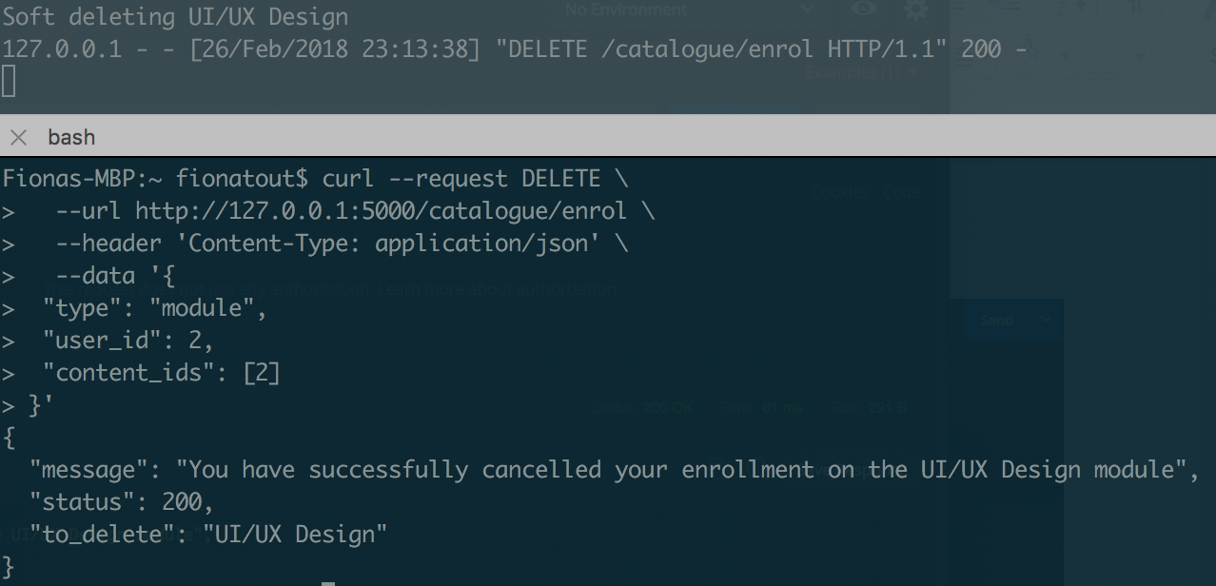

*Figure xx: DELETE request to catalogue/enrol – here the user deletes an enrolment on a module. This BaseClass.soft_delete() function is again called to handle this deletion.*

Question 3

One of the strengths of this design is the composability of services which is achieved through the use of a central and business process agnostic base service. This implements several of the core principles of service orientation and a top down design approach. The base service was created after service oriented analysis of the requisite services and their goals was completed. Global utility functions which were ubiquitous to all services (such as CRUD operations) could then be created. This enables for excellent composability of future services and service consumers from internal and external parties, as the base service acts as a service blueprint for the architecture, whilst also being flexible enough for services to overload any inherited methods with their own functionality. An example of this practice can be seen in the Catalogue service with overrides the ‘*get’* method. As the Catalogue service has been built as an endpoint through which modules, courses and institutions can all be accessed, the service needed to be able to dynamically query any one of the models depending on the request, here we can see how that is implemented versus how the base service get which only ever operates on one model.

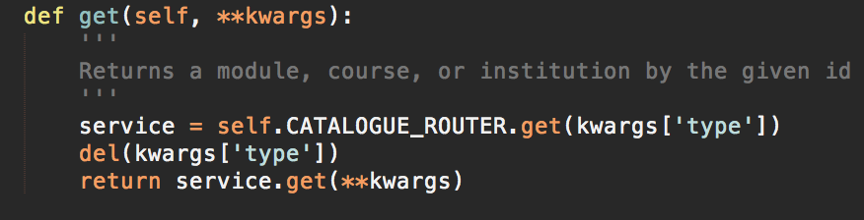

*Fig xx The catalogue service wraps many other services and directs the request according to the ‘type’ argument in the request headers. The CATALOGUER_ROUTER argument is a python dictionary which contains mappings to the services that the catalogue accesses.*

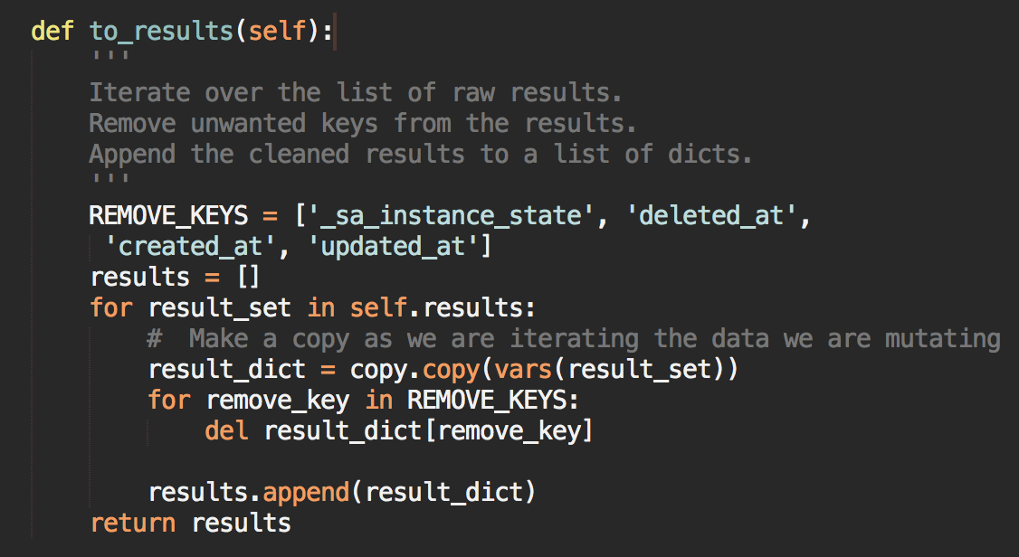

*Figure xx: BaseService.to_results() – This method is called by ‘get’ by not ‘get_raw’ and acts as a pre-processing mechanism to prune unwanted data from the JSON response.*

The pattern of allowing request parameters to be sent HTTP headers enables excellent querying potential for service consumers as it enables them to query any data that is define in the model exposed by the API endpoint. However this design does also create some challenges. As the query parameters are bespoke, there are a myriad of potential queries that could be made for any given endpoint, whilst this is excellent for querying the data, it paradoxically can mean that data is harder to access than through a URL with defined expected arguments.

Maintaining and sharing documentation takes a heavy weighting as if the service consumers are unaware of what they can query in the model then the benefit of this flexibility is lost. The trade-off is between rigidity for the benefit of well defined outcomes and flexibility at the cost of immediate usability. Put another way, rigid URL structures lends to an easier ‘plug and play’ feel API that is more limited in its results, versus a more dynamically queryable API that is harder to immediately learn.

Further complexity arises with the need to implement role based access control across the data that is being queried. TO_COMPLETE

Question 4:

The main challenges of designing this system were building the system with interoperability and service composability at the heart of the design. In order to maximise service reusability services have to be sufficiently agnostic to any given overall business process. Erl makes the argument that the reuse potential of a service is inversely proportional to the quantity of business process specific logic contained in that service(pgs. 35-37). Ideally any given service can be adopted as part of any service composition should its functionality be suited to the purpose. This holy grail of interoperable services is challenging to build for as it requires both very clear understanding of present and potentially future business processes and services requirement that could form part of a service inventory. It also requires strict adherence to predefine service contracts and design approaches as built and output inconsistencies will result in the failure of service composability(Erl, pg. 44). Excellent visibility across the platform from both developers and product managers is essential for this to be a successful operation. This give credence to the core principle of discoverability across services through a programmatic service inventory, or simply a global documentation of services and their input/outputs (the principle of service abstraction (Erl, 294 dictates that internal service logic does not have to be communicated at this level). The success factor of implementation a SOA can be seen as a function of the discoverability and composability of the services.

From a conceptual design perspective decided whether the content providers should self host content or submit it to a central content store was also a challenging decision, with numerous pros and cons to either side. TO_COMPLETE – insert previously written content.

To truly achieve SOA a client written in any language should be able to consume the message out from the API and ingest it straight into its own operations.